|  |  |  |  |  |
| --- | --- | --- | --- | --- |
|  |  | | | |
|  | |  | | |
| Project: | | University Course Scheduler | | |
| Team No.: | | Team Alpha | | |
| Class: | | CSE 3310; Spring 2015 | | |
| Module: | | System Requirements Analysis (SRA) | | |
| Deliverable: | | SRA Document | | |
| Version: | | [0.3] | Date: | [3/26/2015] |

Contributors:

[List names of all team members, each on a separate line, centered]

Mason Wilkens

Revision History

| Version number | Date | Originator | Reason for change | High level description of changes |
| --- | --- | --- | --- | --- |
| 0.1 | 3/24/2015 | Mason Wilkens | Base document | Document Creation |
| 0.2a | 3/26/2015 | Mason Wilkens | Revision | Added Business Objects |
| 0.2b | 3/26/2015 | Mason Wilkens | Revision | Added System Objects |
| 0.3 | 3/26/2015 | Mason Wilkens | Revision | Added UML Class Diagram |
| 0.4 | 3/26/2015 | Mason Wilkens | Revision | Changed Assumptions/Constraints |
|  |  |  |  |  |
|  |  |  |  |  |
|  |  |  |  |  |
|  |  |  |  |  |

TABLE OF CONTENTS

1. Introduction and Project Overview 3

2. Objectives 4

2.1 BUSINESS Objectives 4

2.2 SYSTEM Objectives 4

3. Project Context Diagram 5

4. Systems Requirements 6

4.1 “Website Entry and Promotions” Requirements 6

4.2 “Login” Requirements 6

4.3 “Search” Requirements 6

4.4 “Member Registration” Requirements 6

4.5 “Buy/Sell/Lend/Exchange” Requirements 6

4.6 “Rating” Requirements 6

4.7 “External Advertisement” Requirements 6

5. Software Processes and Infrastructure 7

5.1 Hardware and Infrastructure 7

5.2 UML Diagrams 7

5.3 Conceptual Data Model - Database 7

5.4 Screen Shots 7

5.5 Test Plan 7

6. Assumptions and Constraints 8

6.1 ASSUMPTIONS 8

6.2 CONSTRAINTS 8

6.3 Out of Scope material 8

7. Delivery and Schedule 9

8. Stakeholder Approval Form 10

Appendix: 11

# 1. Introduction and Project Overview

{Describe high-level objectives of the project}

# 2. Objectives

## 2.1 BUSINESS Objectives

The following is a list of business objectives:

**Objective 1**: Register: Every account must include the following:

* Username
* Password
* E-mail address

**Objective 2**: Login: Users must login to the system with a user/password that match with their respective account.

**Objective 3**: Schedule: The system should create schedules from a list of selected courses with their respective section.

**Objective 4**: Edit Schedule: The system should allow the user to add/swap/remove courses from their respective schedule.

**Objective 5**: Block Out Time: The system should allow the user to block out a specified amount of time for that schedule.

## 2.2 SYSTEM Objectives

The following is a list of system objectives:

**Objective 1**: Runs on an Android device.

**Objective 2**: Microsoft SQL will be used as the database.

# 3. Project Context Diagram

{Context diagram displaying all high level components goes here}

# 4. Systems Requirements

{Introduce the following requirement sections that correspond with the “user” functionality. Keep hardware, database, test data, and web hosting to section 5. Add a new section for each category of your requirements. This is the heart of the SRA document, and hence the lengthiest, and should list all requirements of the system. **Please use the designated Requirements Form, insert forms below.**}

## 4.1 “Website Entry and Promotions” Requirements

{List requirements}

## 4.2 “Login” Requirements

{List requirements}

## 4.3 “Search” Requirements

{List requirements}

## 4.4 “Member Registration” Requirements

{List requirements}

## 4.5 “Buy/Sell/Lend/Exchange” Requirements

{List requirements}

## 4.6 “Rating” Requirements

{List requirements}

## 4.7 “External Advertisement” Requirements

{List requirements}

**{Add as many sections as necessary, i.e. 4.8, 4.9 etc., each corresponding to a category of *user* functionality such as examples above.}**

# 5. Software Processes and Infrastructure

## 5.1 Hardware and Infrastructure

{All hardware and infrastructure issues such as hardware type, server location, web hosting and other related material go here}

## 5.2 UML Diagrams

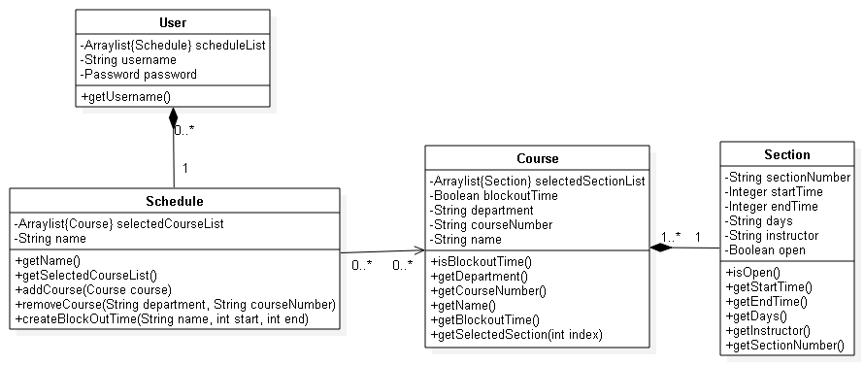

## 5.3 Conceptual Data Model - Database

{All database material goes here, if any}

## 5.4 Screen Shots

{Include any screen shots if you have any here. This may take several pages. If nothing available, mention “None available at this time”}

## 5.5 Test Plan

No one cares about these.

# 6. Assumptions and Constraints

## 6.1 ASSUMPTIONS

The following is a list of assumptions:

* User has a fully functional android device.
* User is 18 or older.
* User knows the department and course number of desired course.

## 6.2 CONSTRAINTS

The following is a list of constraints:

* A user account is valid
* Copyright laws

## 6.3 Out of Scope material

The following is a list of “out of scope” material:

* Post Project maintenance is not covered
* Everything Arun Kalahasti mentions

# 7. Delivery and Schedule

{List all tasks/milestones from start of the project to the end with specific dates for both Anticipated Start & End Dates

|  |  |  |  |  |
| --- | --- | --- | --- | --- |
| Task/Milestone Description | Anticipated Start Date | Anticipated End Date | Status | Comments |
| Prepare Requirements and UML diagram | 2/3/2014 | 3/1/2014 | In Progress |  |
| SRA document (Includes project objectives, Requirements and UML diagrams) | 3/1/2014 | 3/20/2014 | In Progress | Deliverable will be the SRA document. All stakeholders agree on the content of the SRA by signing in section 8. |
| Presentation of SRA | 3/20/2014 | 3/20/2014 |  |  |
| Web page design and Navigation |  |  |  |  |
| Database Design |  |  |  |  |
| Test Data Entry |  |  |  |  |
| Test Plan Delivery |  |  |  |  |
|  |  |  |  |  |
| **… List all tasks …** |  |  |  |  |
|  |  |  |  |  |
| External Documentation (i.e. User Manual) |  |  |  |  |
| Final Milestone: project delivery |  | ∞ | Doomed |  |

# 8. Stakeholder Approval Form

|  |  |  |  |
| --- | --- | --- | --- |
| Stakeholder Name | Stakeholder Role | Stakeholder Comments | Stakeholder Approval Signature and Date |
| Bahram Khalili | Development Mgr |  |  |
| Hafiz Shiekh | Project Assistant |  |  |
| {Team member Name} | Developer |  |  |
| Mason Wilkens | Developer++ |  | C:\Users\Marshal\Pictures\sig.png |
| {Team member Name} | Developer |  |  |
| {Team member Name} | Developer |  |  |
|  |  |  |  |

# Appendix:

{Additional documents or references, if any, go here. If nothing to place in this appendix, just write “None”, do not remove appendix}